**Term Project Proposal - ITM Artificial Intelligence**

**Accurate target location tracking with deep learning approach**

**16102284 Sungho Lee**

**17102049 Jaemin Park**

1. **What is the problem that you will be investigating? Why is it interesting? Why do you choose this topic?**

With the development of IT technology, unmanned systems are gradually being promoted in many fields. In particular, in unmanned stores such as Amazon Go, when a customer puts items in a shopping cart and goes straight to the exit without a checkout process, the product that purchased are identified and automatic payment is made. This technology is possible because many sensors and cameras in the store can be used to determine what products a customer has in their shopping cart. However, these sensors and cameras are expensive to purchase and for operate. In order to reduce cost, many technologies have been studied for accurately locating the target even in a narrow room but there are many obstacles.

Recent preliminary studies have tried to obtain accurate TDOA (difference in signal propagation time of different transmitters (also called tags) measured at receivers (anchors)) through several algorithms, especially deep learning. However, this method simply inferred the correct TDOA value and tracked the location using the hyperbolic equation, and did not use deep learning for the entire process. In addition, the method of estimating the position through TDOA is essential to find the intersection of the hyperbolic equations, but this process needs a lot of computer resources to solve these complex nonlinear equations.

Therefore, to solve these problems, we will build a deep learning model that estimates the exact coordinates of the target by using the TDOA values ​​extracted from the rough space. In particular, we will build a CNN model by converting each TDOA measurement into a TDOA image. We expect that it will be possible to accurately and quickly determine the location of the target even in complex spaces such as unmanned convenience stores and indoor gyms.

1. **What dataset are you using? If needed, how do you plan to collect it? Please describe the dataset as much as you can.**

While training the model, we will use the TDOA and tag coordinate value data measured from real experiments. In the test, a virtual coordinate space as shown in Figure 1 was defined using 4 anchors, tags, and a Central Computing Unit (CCU). The TDOA measurement was made in the environment where the tag moves, and the target moves randomly and generates position coordinate log data every 0.1 seconds. Using these data, data as shown in Figure 2 was created. In the generated data, we will add additional noise to the TDOA value or change it to a 0 value to assume a rough environment. From the official announcement of the measuring device in Figure 3, the noise will be a value that more than the mechanical limit of the device which is 10cm.



**< Fig3. official article of device peformance>**

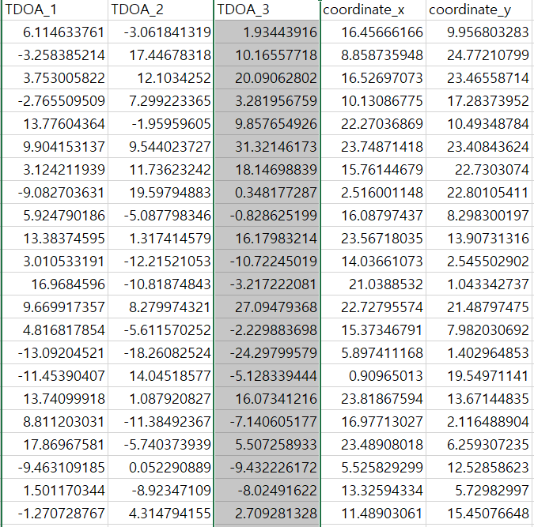

**<Fig2. Examples of measured data>**

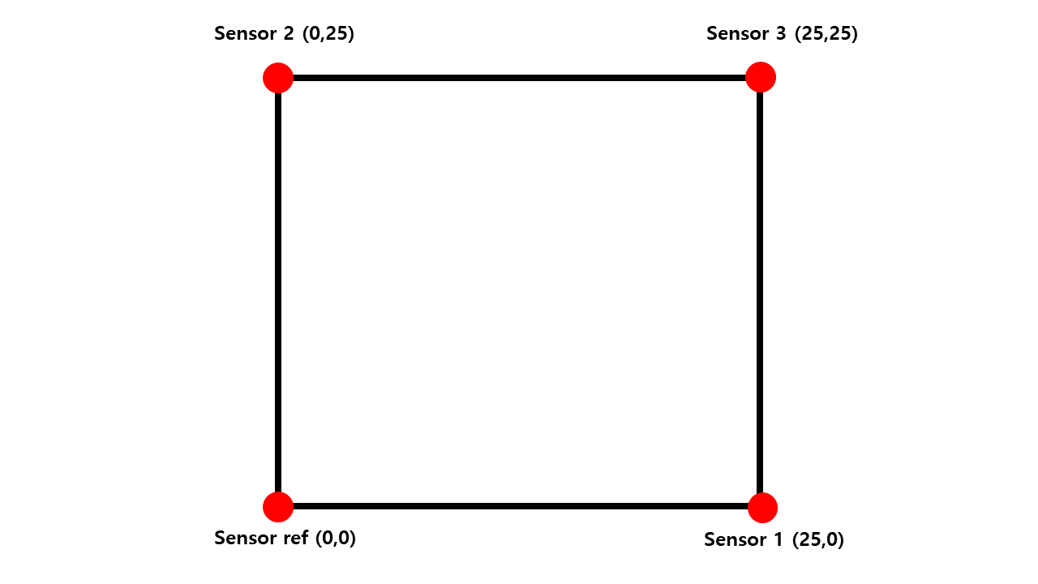

**<Fig1. Virtual coordinate space>**

1. **What method or algorithm are you proposing? If there are existing implementations, will you use them and how? How do you plan to improve or modify such implementations?**

As mentioned earlier, we will train the CNN model by imaging the TDOA value. We propose a TDOA image based target tracking model to provide robust target tracking results in cluttered environment. Fig. 4 represents the overall procedure of model, which is composed of three steps; (i) measurement to image conversion (ii) mask generation (ii) CNN model for estimation. When TDOA measurements are obtained at CCU, each TDOA measurement is converted into image. Then, a mask is created to deal with measurement errors, where the value of mask can be determined by human (based on observation of environments) or deep learning architecture. By combining and treating TDOA images with masks as input data, we train a CNN model with fully connected layer to estimate target position. In section 4 about reference paper, there was similar subject but used LSTM model. However, we are going to convert TDOA to image and use CNN to predict precise target tracking result.

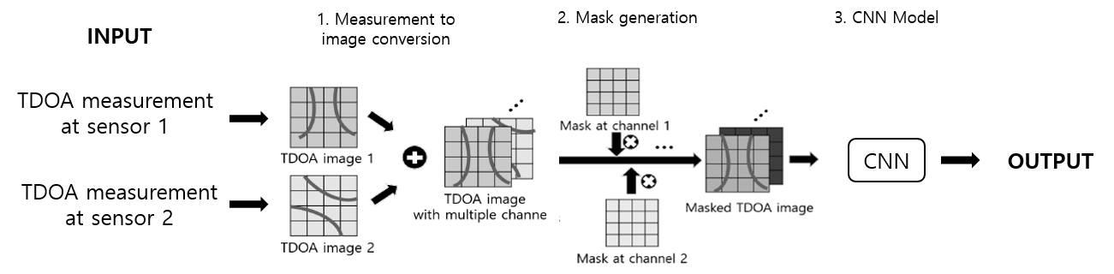

<Fig 4. System architecture for our proposed tracking model>

1. **What reading do you examine to provide context and background? What papers (previous works) do you refer to?**
2. Convolutional Neural Networks for Position Estimation in TDoA-Based Locating Systems (Niitsoo et.al 2018)

In this paper, they present a model to determine the exact location by combining TDoA and CNN deep learning model. Unlike in single-path scenarios, it is difficult to calculate accurate TDoA in multi-path scenarios. To overcome this problem, this paper solved the problem using CNN deep learning. The above paper differs from our goal to solve the communication uncertainty of the sensor due to obstacles. But the fundamental purpose of accurate location estimation using TDoA and CNN models is the same, I think this is a paper has many references, such as the model structure.

# DeepTAL: Deep Learning for TDOA-Based Asynchronous Localization Security With Measurement Error and Missing Data (Xue et.al 2019)

# Similar to our subject, this paper proposed an improved target location measurement algorithm using deep learning to overcome various errors such as data omissions due to obstacles, sensor errors, and network attacks. LSTM is applied to achieve stronger learning and better representation of target states and TDOA predictions. Experiments using the proposed algorithm showed that the accuracy was efficiently improved even in the case of measurement error or data omission. Although the definition of the problem to be solved is similar, they have successfully solved the problem using an LSTM network, unlike our approach of using a CNN network.

1. **How will you evaluate your results? Qualitatively, what kind of results do you expect (e.g., plots or figures)? Quantitatively, what kind of analysis will you use to evaluate and/or compare your results? (e.g., what performance metrics)?**

The difference between the model and the true value will be counted and expressed as a bar plot. By measuring the coordinates of the tag obtained through the trained model and the coordinate distance of the actual tag, we will train the model by reducing the distance difference, and evaluate how accurately the tag was measured by using distance difference. In addition, we will compare the three-layer FCNNs model with TDOA values input and tag coordinates output to see how more effective our proposed algorithm is in a rough environment where errors occur frequently.